XIV International scientific conference  of young scientists, students, master students and post-graduates | 
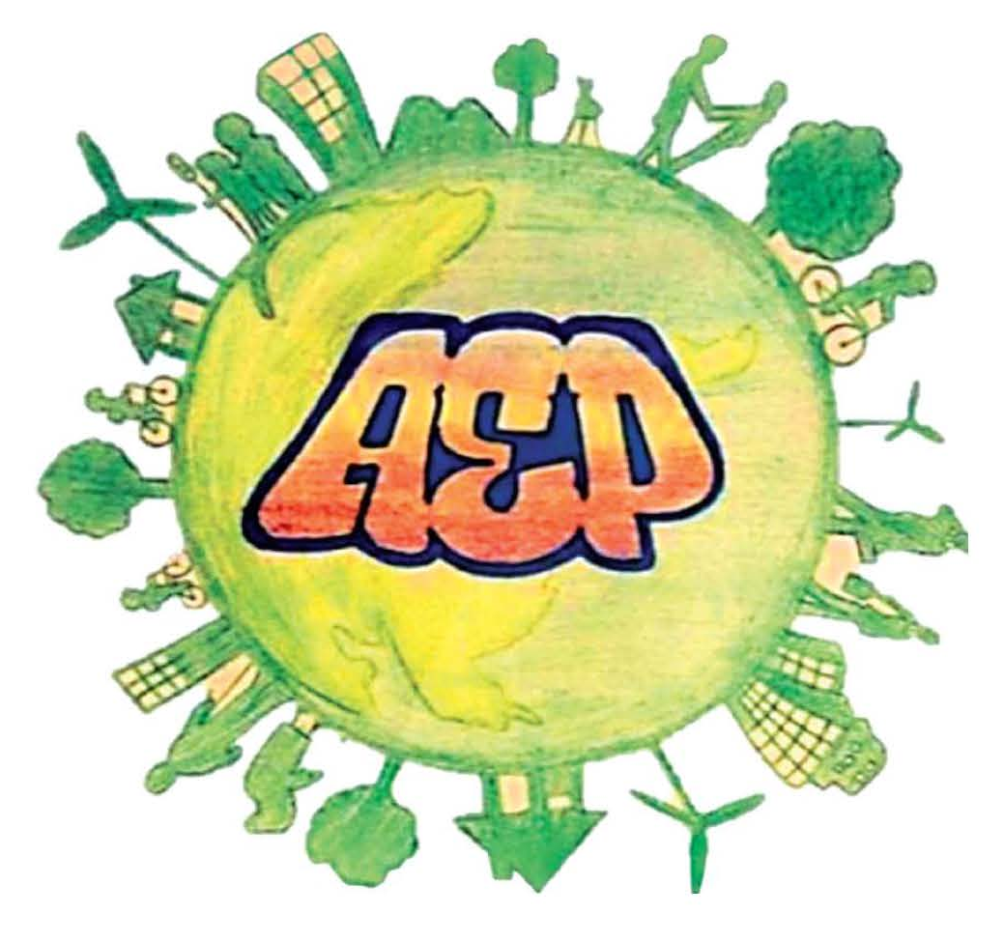

«ACTUAL ENVIRONMENTAL PROBLEMS» 2024

FIRST INFORMATION LETTER

BELARUSIAN STATE UNIVERSITY
INTERNATIONAL SAKHAROV ENVIRONMENTAL INSTITUTE

DEAR COLLEAGUES!

We invite you to take part in the work of
XIV International scientific conference of young scientists, students, master students and post-graduates
«ACTUAL ENVIRONMENTAL PROBLEMS»

Minsk, December 5 – December 6, 2024

Working language of the conference – English.

Target Audience:
Employees of research organizations and enterprises of environmental and biomedical profile, students, master students, post-graduate students and young scientists, representatives of public organizations, business, and the media are invited to participate in the conference.

The main directions of the conference:
- Socio-ecological, ethical and pedagogical problems of our time.
- Medical ecology.
- Problems of modern environmental safety (biomonitoring, bioindication, biorehabilitation, radioecology and radiation safety, environmental monitoring, management and audit. Information systems and technologies in ecology, energy-efficient technologies).
- Bioinformatics. Modern approaches and methods to the study of biomolecules.

Form of participation in the conference:
- Presentation at the section session (up to 10 minutes).
- Poster (A1 format, vertical layout).
- Correspondence participation (with presentation of theses of the report and their publication in the conference proceedings).
The format of the conference supports face-to-face (presentation or poster participation), correspondence participation.

Conference location: International Sakharov Environmental Institute of Belarusian State University (hereinafter referred to as the ISEU), address: Minsk, 23/1 Dolgobrodskaya Str.

Conference organizers: Ministry of education of the Republic of Belarus; Ministry of Natural Resources and Environmental Protection of the Republic of Belarus; Public Council of the Basic Organization for Environmental Education of the CIS countries; Belarusian State University; ISEU.

Key dates:
Acceptance of applications (registration) – until October 15, 2024.
Submission of materials in paper form – until October 25, 2024.
To participate in the conference, it is necessary to go through electronic registration on the website REGISTRATION FORM (← active link) and attach materials in English and Russian languages designed in accordance with the requirements. Printed and signed by all authors, 1 version of the abstract should be sent to the address of the organizing committee of the conference (23 Dolgobrodskaya Street, Minsk, room 414 (for Lobai M.V.), room 421 (for Vasyukevich E.N.)).).
From one author to participation in the conference no more than 3 publications are allowed. The number of participants from the university, faculty or department is not limited.
Requirements for the design of materials and a template for the design of materials are available on the conference website (http://rfc.iseu.by/).

The original text must be at least 75 %.
The working version of the conference program will be posted after November 15, 2024 on the website http://rfc.iseu.by/ and will serve as an invitation to participate in the conference.
The collection of materials will be published as soon as it is ready and posted on the conference website after its completion. The authors are responsible for the materials provided for the conference. Abstracts containing a large number of grammatical mistakes will not be considered. The Organizing Committee has the right to reject articles in case of discrepancy to their scientific topics and the level of the conference, violation of registration requirements and established deadlines for submission of materials.

Conference participants will receive certificates in case of full-time participation.

The sending party pays travel, accommodation and food expenses.

Contact Information:
Information about the conference is available on the website.
http://rfc.iseu.by/

Contact telephones:
+375 (33) 638 73 11 – Lobai Marina Valerievna
(general information about the conference)
+375 (29) 974 58 45 – Vasyukevich Elena Nikolaevna

E-mail: iseu2024@gmail.com

